**UNIT 1 UNDERSTANDING CLOUD COMPUTING**

**Basic Concepts and Terminology - Cloud Computing Architectural Framework - Types of Clouds - pros and cons of cloud computing – Cloud Characteristics - difference between web 2.0 and cloud - key challenges in cloud computing - Major Cloud players - Virtualization in Cloud Computing - Parallelization in Cloud Computing - cloud resource management – Cloud Enabling Technology.**

# HISTORY OF CLOUD COMPUTING:

Before emerging the cloud computing, there was Client/Server computing which is basically a centralized storage in which all the software applications, all the data and all the controls are resided on the server side.

If a single user wants to access specific data or run a program, he/she need to connect to the server and then gain appropriate access, and then he/she can do his/her business.

Then after, distributed computing came into picture, where all the computers are networked together and share their resources when needed.

On the basis of above computing, there was emerged of cloud computing concepts that later implemented.

At around in 1961, John MacCharty suggested in a speech at MIT that computing can be sold like a utility, just like a water or electricity. It was a brilliant idea, but like all brilliant ideas, it was ahead if its time, as for the next few decades, despite interest in the model, the technology simply was not ready for it.

But of course time has passed and the technology caught that idea and after few years we mentioned that:

In 1999, Salesforce.com started delivering of applications to users using a simple website. The applications were delivered to enterprises over the Internet, and this way the dream of computing sold as utility were true.

In 2002, Amazon started Amazon Web Services, providing services like storage, computation and even human intelligence. However, only starting with the launch of the Elastic Compute Cloud in 2006 a truly commercial service open to everybody existed.

In 2009, Google Apps also started to provide cloud computing enterprise applications.same year Microsoft launched Windows Azure, and companies like Oracle and HP have all joined the game. This proves that today, cloud computing has become mainstream.

# CLOUD COMPUTING:

Cloud computing means on demand delivery of IT resources via the internet with pay-as-you- go pricing. It provides a solution of IT infrastructure in low cost.

# Cloud computing needs:

Actually, Small as well as some large IT companies follows the traditional methods to provide the IT infrastructure. That means for any IT company, we need a Server Room that is the basic need of IT companies.

In that server room, there should be a database server, mail server, networking, firewalls, routers, modem, switches, QPS (Query Per Second means how much queries or load will be handled by the server) , configurable system, high net speed and the maintenance engineers.

To establish such IT infrastructure, we need to spend lots of money. To overcome all these problems and to reduce the IT infrastructure cost, Cloud Computing comes into existence.

# Characteristics of Cloud Computing

The characteristics of cloud computing are given below:

# Agility

The cloud works in the distributed computing environment. It shares resources among users and works very fast.

# High availability and reliability

Availability of servers is high and more reliable, because chances of infrastructure failure are minimal.

# High Scalability

Means "on-demand" provisioning of resources on a large scale, without having engineers for peak loads.

# Multi-Sharing

With the help of cloud computing, multiple users and applications can work more efficiently with cost reductions by sharing common infrastructure.

# Device and Location Independence

Cloud computing enables the users to access systems using a web browser regardless of their location or what device they use e.g. PC, mobile phone etc. As infrastructure is off-site (typically provided by a third-party) and accessed via the Internet, users can connect from anywhere.

# Maintenance

Maintenance of cloud computing applications is easier, since they do not need to be installed on each user's computer and can be accessed from different places. So, it reduces the cost also.

# Low Cost

By using cloud computing, the cost will be reduced because to take the services of cloud computing, IT company need not to set its own infrastructure and pay-as-per usage of resources.

# Services in pay-per-use mode

Application Programming Interfaces (APIs) are provided to the users so that they can access services on the cloud by using these APIs and pay the charges as per the usage of services.

# Architectural framework:

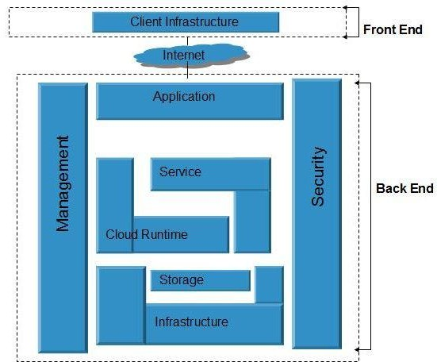

Cloud Computing architecture refers to the various components and sub-components of cloud that constitute the structure of the system.

cloud computing architecture consists of:

* A front-end platform that can include fat clients, thin clients, and mobile devices
* Back-end platforms, such as servers and storage
* Cloud-based delivery
* A network (internet, intranet)

At its most basic, cloud architecture can be classified into two sections: front-end and back- end, connected to each other via a virtual network or the internet. There are other parts of cloud architecture including middleware, cloud resources, etc., but for now we’ll just review the basics.

# Front End Cloud Computing

Front-end is the side that is visible to the client, customer, or user. Front-end pieces include the user interface, and the client’s computer system or network that is used for accessing the cloud system. You have probably noticed that different cloud computing systems use different user interfaces—for example, not only can you choose from a variety of web browsers (including Chrome, Safari, Firefox, etc.), but the Google Docs user interface is different than that of Salesforce.

# Back End Cloud Computing

On the other hand, the back-end pieces are on the side used by the service provider. These include various servers, computers, data storage systems, virtual machines, and programs that together constitute the cloud of computing services. The back-end side also is responsible for providing security mechanisms, traffic control and protocols that connect networked computers for communication.

To briefly summarize: the front-end is the part you see, and the back-end is the computing that happens behind the scenes.

# Cloud Based Delivery

As we’ve discussed above, cloud computing services are everywhere these days. For example, if your company uses Salesforce or QuickBooks—or you use Google Drive or Office 365 at home or work, you’re a cloud computing user. These are all examples of subscriptions a company or individual can purchase that enable them to use the software, typically known as Software-as-a-Service, or SaaS.

Because of technology like virtualization and hypervisors, it’s possible for many virtual servers to exist on a single physical server. These technologies power other cloud subscriptions like Platform-as-a-Service (PaaS), Infrastructure-as-a-Service (IaaS), and more.

# Cloud Services Network

Cloud services can be delivered publicly or privately using the internet and can also remain within a company’s network when delivered over an intranet. Sometimes, organizations make use of a combination of both.

No matter where the actual “cloud” is—a company’s own data center or a service provider’s data center, cloud computing uses networking to enable convenient, on - demand access to a shared pool of computing resources like networks, storage, servers, services, and applications. By using virtualization, these assets can be provisioned and released quickly and easily as necessary.

Types of cloud:

Public Cloud

Public cloud allows the accessibility of systems and services easily to general public. Eg: Amazon, IBM, Microsoft, Google, Rackspace etc.

# Advantages of Public Cloud Model

* 1. **Low Cost**

Public cloud is having low cost as compared to private or hybrid cloud, because it shares same resources with large number of consumer.

# Reliable

Public cloud provides large number of resources from different locations, if any of the resource fail, public cloud can employ another one.

# Flexible

It is very easy to integrate public cloud with private cloud and hence it gives flexible approach to consumers.

# Location Independent

It ensures the independency of location, because public cloud services are delivered through Internet.

# High Scalability

Cloud resources are available as per the demand from the pool of resources that means they can be scaled up or down according to the requirement.

# Disadvantages of Public Cloud Model

1. **Low security**

In public cloud model, data is present off-site and resources are shared publicly. Hence it does not ensure the high level security.

# Less customizable

It is less customizable than private cloud.

# Private Cloud

The Private cloud allows the accessibility of systems and services within the organization. Private cloud is operated only within a particular organization. But it will be managed internally or by third party.

# Advantages of Private Cloud Model

1. **High security and privacy**

Private cloud resources are shared from distinct pool of resources and hence highly secured.

# More Control

Private clouds have more control on its resources and hardware than public cloud because it is accessed only within the boundary of an organization.

# Disadvantages of Private Cloud Model

1. **Restriction**

Private cloud is only accessible locally and it is very difficult to deploy globally.

# More Cost

cloud is having more cost than public clouds.

# Inflexible price

In order to fulfill demands, purchasing new hardware is very costly.

# Less Scalability

Private clouds are scaled only within capacity of internal hosted resources.

# Hybrid Cloud

The Hybrid cloud is the mixture of public and private cloud. Non-critical activities are performed by public cloud while critical activities are performed by private cloud.

# Advantages of Hybrid Cloud Model

1. **Scalable**

It provides both the features of public and private cloud scalability.

# Flexible and secure

It provides secure resources because of private cloud and scalable resources because of public cloud.

# Cost effective

It is having less cost as compared to private cloud.

# Disadvantages of Hybrid Cloud Model

1. **Networking issues**

Networking becomes complex because of private and public cloud.

# Security Compliance

It is necessary to ensure that cloud services are compliant with the security policies of an organization.

# PROS AND CONS OF CLOUD:

**Advantages of Cloud Computing**

There are various advantages of cloud computing technology. The important advantages of cloud computing are given below.

# Lower cost computer for users

In cloud, you don't require a high-powered (and accordingly high-priced) computer to run cloud computing's web based applications because applications run on cloud not on desktop PC or laptop.

# Lower IT infrastructure cost

By using cloud computing, you need not to invest in larger numbers of more powerful servers, you also need not to require the IT staff for handling such powerful servers.

# Fewer maintenance cost

The maintenance cost in cloud computing greatly reduces both hardware and software maintenance for organizations of all sizes.

# Lower Software Cost

It reduces the software cost because you don't need to purchase separate software packages for each computer in the organization.

# Instant software updates

Another software-related advantage in cloud computing is that users don't need to face with the choice between obsolete software and high upgrade costs. If the app is web- based, updates happen automatically and are available next time when the user logs in to the cloud.

# Increased computing Power

The execution capacity of cloud servers are very high. It processes the application very fast.

# Unlimited storage capacity

Cloud offers you a huge amount of storage capacity like 2000 GB or more than that if required.

# Disadvantages of Cloud Computing

There are various disadvantages of cloud computing technology. The important disadvantages of cloud computing are given below.

# Require a constant Internet Connection

Cloud computing is impossible without Internet connection. To access any applications and documents you need a constant Internet connection.

# Require High Speed Internet connection

Similarly, a low-speed Internet connection makes cloud computing painful at best and often impossible. Web based apps often require a lot of bandwidth to download, as need to download large documents.

# Stored Data Might Not Be Secure

With cloud computing, all your data is stored in the cloud. That's all well and good, but how secure is the cloud? Can't unauthorized users gain access to your confidential data

**Difference: Cloud and Web 2.0**

|  |  |
| --- | --- |
| **Cloud Computing** | **Web 2.0** |
| It is more specific and definite | Programming and business models |
| It is a way of searching through data. | It is sharing entire pieces of data between |
| different websites. |
| Cloud computing is about computers. | Web 2.0 is about people. |
| The internet as a computing platform | Attempt to explore and explain the business |
| rules of that platform |
| Google apps are considered in Cloud | A web-based application is considered in |
| computing. | Web 2.0. |
| It is a business model for hosting these | It is a technology which allows webpages to |
| services. | act as more responsive applications |

# Challenges:

Cloud computing is used for enabling global access to mutual pools of resources such as services, apps, data, servers, and computer networks. It is done on either a third-party server located in a data center or a privately owned cloud. This makes data-accessing contrivances more reliable and efficient, with nominal administration effort.

Because cloud technology depends on the allocation of resources to attain consistency and economy of scale, similar to a utility, it is also fairly cost-effective, making it the choice for many small businesses and firms.

But there are also many challenges involved in cloud computing, and if you’re not prepared to deal with them, you won’t realize the benefits. Here are six common challenges you must consider before implementing cloud computing technology.

# Cost

Cloud computing itself is affordable, but tuning the platform according to the company’s needs can be expensive. Furthermore, the expense of transferring the data to public clouds can prove to be a problem for short-lived and small-scale projects.

Companies can save some money on system maintenance, management, and acquisitions. But they also have to invest in additional bandwidth, and the absence of routine control in an infinitely scalable computing platform can increase costs.

# Service Provider Reliability

The capacity and capability of a technical service provider are as important as price. The service provider must be available when you need them. The main concern should be the service provider’s sustainability and reputation. Make sure you comprehend the techniques via which a provider observes its services and defends dependability claims.

# Downtime

Downtime is a significant shortcoming of cloud technology. No seller can promise a platform that is free of possible downtime. Cloud technology makes small companies reliant on their connectivity, so companies with an untrustworthy internet connection probably want to think twice before adopting cloud computing.

# Password Security

Industrious password supervision plays a vital role in cloud security. However, the more people you have accessing your cloud account, the less secure it is. Anybody aware of your passwords will be able to access the information you store there.

Businesses should employ multi-factor authentication and make sure that passwords are protected and altered regularly, particularly when staff members leave. Access rights related to passwords and usernames should only be allocated to those who require them.

# Data privacy

Sensitive and personal information that is kept in the cloud should be defined as being for internal use only, not to be shared with third parties. Businesses must have a plan to securely and efficiently manage the data they gather.

# Vendor lock-in

Entering a cloud computing agreement is easier than leaving it. “Vendor lock-in” happens when altering providers is either excessively expensive or just not possible. It could be that the service is nonstandard or that there is no viable vendor substitute.

It comes down to buyer carefulness. Guarantee the services you involve are typical and transportable to other providers, and above all, understand the requirements.

Cloud computing is a good solution for many businesses, but it’s important to know what you’re getting into. Having plans to address these six prominent challenges first will help ensure a successful experience.

# Cloud players:

Top 5 cloud players

**#1 Microsoft** remains an absolute lock at the top due to four factors: its deep involvement at all three layers of the cloud (IaaS, PaaS and SaaS); its unmatched commitment to developing and helping customers deploy AI, ML and Blockchain in innovative production environments; its market-leading cloud revenue, which I estimate at about $16.7 billion for the trailing 12 months (***not*** to be confused with the forward-projected $20.4 billion annualized run rate the company released on Oct. 26); and the extraordinary vision and leadership of CEO Satya Nadella.

**#2 Amazon** might not have the end-to-end software chops of the others in the Top 5 but it was and continues to be the poster-child for the cloud-computing movement: the first-moving paradigm-buster and category creator. I believe Amazon will make some big moves to bolster its position in software, and no matter how you slice it, the $16 billion in trailing-12-month cloud revenue from AWS is awfully impressive.

**#3 IBM** has leapfrogged both Salesforce.com (formerly tied with Amazon for #2 and now in the #4 spot) and SAP (formerly #4) on the strength of its un-trendy but highly successful emphasis on transforming its vast array of software expertise and technology from the on- premises world to the cloud. In so doing, IBM has quietly created a $15.8-billion cloud business (again on trailing-12-month basis) that includes revenue of $7 billion from helping big global corporations convert legacy systems to cloud or cloud-enabled environments. And like #1 Microsoft, IBM plays in all three layers of the cloud—IaaS, PaaS and SaaS—which is hugely important for the elite cloud vendors because it allows them to give customers more choices, more seamless integration, better cybersecurity, and more reasons for third-party developers to rally to the IBM Cloud. Plus, its relentless pairing of "cloud and cognitive" is an excellent approach toward weaving AI and ML deeply into customer-facing solutions.

**#4 Salesforce.com** falls a couple of spots from its long-time tie with Amazon at #2 but—and this will be the case as long as founder Marc Benioff is CEO—remains a powerful source of digital innovation and disruptive strategy. However, to remain in the rarified air near the top of the Cloud Wars Top 10, Benioff and Salesforce must find a way to extend their market impact beyond their enormously successful SaaS business and become more of a high-impact player in the platform or PaaS space. At this stage, it's simply not possible for Salesforce to become a player in IaaS, so Benioff needs to crank up the genius machine and hammer his way into top contention as a platform powerhouse.

**#5 SAP** has what all of the other cloud vendors would kill for: unmatched incumbency within all of the world's leading corporations as the supplier of mission-critical business applications that run those companies. It's also fashioned, under CEO Bill McDermott, powerful new partnerships with Amazon and Google to complement its long-standing relationships with

As the cloud technology is providing users with so many benefits, these benefits must have to be categorized based on users requirement. Cloud deployment model represents the exact category of cloud environment based on proprietorship, size, and access and also describes the nature and purpose of the cloud. Most organizations implement the cloud infrastructure to

IBM and Microsoft, all of which give customers a heightened sense of confidence that SAP will be willing and able to play nice in heterogeneous environments. Plus, SAP's HANA technology is now in full deployment across thousands of businesses, and as it takes root and SAP continues to rationalize its massive product portfolio around HANA in the cloud, SAP has a very bright future ahead of it in the cloud.

**Deployment models:**

minimize capital expenditure & regulate operating costs.

The National Institute of Standards and Technology (NIST) is an agency under the scope of US Department of Commerce which is responsible for expounding & defining standards in Science and Technology. The Computer Security Division of NISD has provided a formal definition of Cloud computing. The US government is a major consumer of computer technology and also one of the major cloud computing network users. According to the NIST working definition of cloud, deployment model is one of the two categories of model illustrated by NIST. The NIST model doesn't require a cloud technology to use virtualization to share resources. Cloud support multi-tenancy; multi-tenancy is the concept of sharing of resources among two or more clients. The latest NIST model of cloud computing requires virtualization and utilizes the concept of multi-tenancy.

As the cloud computing us approaching towards a set of interacting components, such as Service-oriented Architecture, users can expect the future versions of the NIST model may include more features also.

# Explaining Deployment Model

To know which deployment model matches your requirement and desire, it is necessary for

users as well as learners to understand the four sub-categories of models for deployment.

**Public Cloud** is a type of cloud hosting that allows the accessibility of systems & its services to its clients/users easily. Some of the examples of those companies which provide public cloud facilities are IBM, Google, Amazon, Microsoft, etc. This cloud service is open for use. This type of cloud computing is a true specimen of cloud hosting where the service providers render services to various clients. From the technical point of view, there is the least difference between private clouds and the public clouds along with the structural design. Only the security level depends based on the service providers and the type of cloud clients use. Public cloud is better suited for business purposes for managing the load. This type of cloud is economical due to the decrease in capital overheads.

# The advantages of the Public cloud are:

* Flexible
* Reliable
* High Scalable
* Low cost
* Place independence

This type also holds some disadvantages such as:

* Less Secured
* Poor Customizable

**Private Cloud** also termed as 'Internal Cloud'; which allows the accessibility of systems and services within a specific boundary or organization. The cloud platform is implemented in a cloud-based secure environment that is guarded by advanced firewalls under the surveillance of the IT department that belongs to a particular organization. Private clouds permit only authorized users, providing the organizations greater control over data and its security. Business organizations that have dynamic, critical, secured, management demand based requirement should adopt Private Cloud.

# The advantages of using private cloud are:

**Highly private and secured:** Private cloud resource sharing is highly secured.

**Control Oriented:** Private clouds provide more control over its resources than public cloud as it can be accessed within the organization's boundary.

# The Private cloud has the following disadvantages:

**Poor scalability:** Private type of clouds is scaled within internal limited hosted resources.

**Costly:** As it provides secured and more features, so it's more expensive than a public cloud.

**Pricing:** is inflexible; i.e., purchasing new hardware for up-gradation is more costly.

**Restriction:** It can be accessed locally within an organization and is difficult to expose globally.

**Hybrid Cloud** is another cloud computing type, which is integrated, i.e., it can be a combination of two or more cloud servers, i.e., private, public or community combined as one architecture, but remain individual entities. Non-critical tasks such as development and test workloads can be done using public cloud whereas critical tasks that are sensitive such as organization data handling are done using a private cloud. Benefits of both deployment models, as well as community deployment model, are possible in a hybrid cloud hosting. It can cross isolation and overcome boundaries by the provider; hence, it cannot be simply categorized into any of the three deployments - public, private or community cloud.

# Advantages of Hybrid Cloud Computing are:

* Flexible
* Secure
* Cost Effective
* Rich Scalable

**Disadvantages of Hybrid Cloud are:**

* Complex networking problem
* Organization's security Compliance

# Community Cloud

It is another type of cloud computing in which the setup of the cloud is shared manually among different organizations that belong to the same community or area. Example of such a community is where organizations/firms are there along with the financial institutions/banks. A multi-tenant setup developed using cloud among different organizations that belong to a particular community or group having similar computing concern.

For joint business organizations, ventures, research organizations and tenders community cloud is the appropriate solution. Selection of right type of cloud hosting is essential in this case. Thus, community-based cloud users need to know and analyze the business demand first.

# Virtualization

The term 'Virtualization' can be used in many respect of computer. It is the process of creating a virtual environment of something which may include hardware platforms, storage devices, OS, network resources, etc.

Virtualization is the ability which allows sharing the physical instance of a single application or resource among multiple organizations or users. This technique is done by assigning a name logically to all those physical resources & provides a pointer to those physical resources based on demand.

Over an existing operating system & hardware, we generally create a virtual machine which and above it we run other operating systems or applications. This is called Hardware Virtualization. The virtual machine provides a separate environment that is logically distinct from its underlying hardware. Here, the system or the machine is the host & virtual machine is the guest machine. This virtual environment is managed by a firmware which is termed as a hypervisor.

There are several approaches or ways to virtualizes cloud servers.

These are:

**Grid Approach:** where the processing workloads are distributed among different physical servers, and their results are then collected as one.

**OS - Level Virtualization:** Here, multiple instances of an application can run in an isolated form on a single OS

**Hypervisor-based Virtualization:** which is currently the most widely used technique

With hypervisor's virtualization, there are various sub-approaches to fulfill the goal to run multiple applications & other loads on a single physical host. A technique is used to allow virtual machines to move from one host to another without any requirement of shutting down. This technique is termed as "Live Migration". Another technique is used to actively load balance among multiple hosts to efficiently utilize those resources available in a virtual machine, and the concept is termed as Distributed Resource Scheduling or Dynamic Resource Scheduling.

The virtualization of cloud has been categorized into four different types based on their characteristics. These are:

Hardware Virtualization

* Full Virtualization
* Emulation Virtualization
* Para-virtualization
* Software Virtualization
* OS Virtualization
* Server Virtualization
* Storage Virtualization

**Virtualization works in cloud:**

Virtualization plays a significant role in cloud technology and its working mechanism. Usually, what happens in the cloud - the users not only share the data that are located in the cloud like an application but also share their infrastructures with the help of virtualization. Virtualization is used mainly to provide applications with standard versions for the cloud customers & with the release of the latest version of an application the providers can efficiently provide that application to the cloud and its users and it is possible using virtualization only. By the use of this virtualization concept, all servers & software other cloud providers require those are maintained by a third-party, and the cloud provider pays them on a monthly or yearly basis.

In reality, most of the today's hypervisor make use of a combination of different types of hardware virtualization. Mainly virtualization means running multiple systems on a single machine but sharing all resources (hardware) & it helps to share IT resources to get benefit in the business field.

# Hardware Virtualization

It is the abstraction of computing resources from the software that uses cloud resources. It involves embedding virtual machine software into the server's hardware components. That software is called the hypervisor. The hypervisor manages the shared physical hardware resources between the guest OS & the host OS. The abstracted hardware is represented as actual hardware. Virtualization means abstraction & hardware virtualization is achieved by abstracting the physical hardware part using Virtual Machine Monitor (VMM) or hypervisor. Hypervisors rely on command set extensions in the processors to accelerate common virtualization activities for boosting the performance. The term hardware virtualization is used when VMM or virtual machine software or any hypervisor gets directly installed on the hardware system. The primary task of the hypervisor is to process monitoring, memory & hardware controlling. After hardware virtualization is done, different operating systems can be installed, and various applications can run on it. Hardware virtualization, when done for server platforms, is also called server virtualization.

Hardware virtualization is of three kinds. These are:

1. **Full Virtualization:** Here the hardware architecture is completely simulated. Guest software doesn't need any modification to run any applications.
2. **Emulation Virtualization:** Here the virtual machine simulates the hardware & is independent. Furthermore, the guest OS doesn't require any modification.
3. **Para-Virtualization:** Here, the hardware is not simulated; instead the guest software runs its isolated system

# Software virtualization

It is also called application virtualization is the practice of running software from a remote server. Software virtualization is similar to that of virtualization except that it is capable to abstract the software installation procedure and create virtual software installation. Many applications & their distributions became typical tasks for IT firms and departments. The mechanism for installing an application differs. So virtualized software is introduced which is an application that will be installed into its self-contained unit and provide software virtualization. Some of the examples are Virtual Box, VMware, etc.

**The DLL (Data Link Layer)** redirect the entire virtualized program's calls to the file system of the server. When the software is run from the server in this procedure, no changes are required to be made on the local system.

**Ease of Client Deployment:** Virtual software makes it easy to link a file in a network or file copying to the workstation.

**Software Migration:** Before the concept of virtualization, shifting from one software platform to another was time-consuming; and has a significant impact on the end-system user. The software virtualization environment makes migration easier.

**Easy to Manage:** Application updates become a simple task.

It is the division of physical server into several virtual servers and this division is mainly done to improvise the utility of server resource. In other word it is the masking of resources that are located in server which includes the number & identity of processors, physical servers & the operating system. This division of one physical server into multiple isolated virtual servers is done by server administrator using software. The virtual environment is sometimes called the virtual private-servers.

# Server virtualization:

In this process, the server resources are kept hidden from the user. This partitioning of physical server into several virtual environments; result in the dedication of one server to perform a single application or task.

This technique is mainly used in web-servers which reduces the cost of web-hosting services. Instead of having separate system for each web-server, multiple virtual servers can run on the same system/computer.

# the primary uses of server virtualization are:

* To centralize the server administration
* Improve the availability of server
* Helps in disaster recovery
* Ease in development & testing
* Make efficient use of server resources.

# For Server Virtualization, there are three popular approaches.

These are:

* Virtual Machine model
* Para-virtual Machine model

# Operating System (OS) layer Virtualization

**Virtual Machine model:** are based on host-guest paradigm, where each guest runs on a virtual replica of hardware layer. This technique of virtualization provide guest OS to run without modification. However it requires real computing resources from the host and for this a hypervisor or VM is required to coordinate instructions to CPU.

**Para-Virtual Machine model:** is also based on host-guest paradigm & uses virtual machine monitor too. In this model the VMM modifies the guest operating system's code which is called 'porting'. Like that of virtual machine, similarly the Para-virtual machine is also capable of executing multiple operating systems. The Para-virtual model is used by both Xen & UML.

**Operating System Layer Virtualization:** Virtualization at OS level functions in a different way and is not based on host-guest paradigm. In this model the host runs a single operating system kernel as its main/core and transfers its functionality to each of the guests. The guest must use the same operating system as the host. This distributed nature of architecture eliminated system calls between layers and hence reduces overhead of CPU usage. It is also a must that each partition remains strictly isolated from its neighbors because any failure or security breach of one partition won't be able to affect the other partitions.

# Storage virtualization:

It pools the physical storage from different network storage devices and makes it appear to be a single storage unit that is handled from a single console. As we all know there has been a strong bond between physical host & locally installed storage device; and with the change in paradigm, local storage is no longer needed. More advanced storage has come to the market with an increase in functionality. Storage virtualization is the significant component of storage servers & facilitates management and monitoring of storage in a virtualized environment.

Storage virtualization helps the storage administrator to backup, archive and recovery data more efficiently, in less amount of time by masking the actual complexity of SAN (Storage Area Network). Through the use of software hybrid appliances, the storage administrator can implement virtualization.

**Storage virtualization** is becoming more and more important in different forms such as:

**Storage Tiering:** Using the storage technique as a bridge or as a stepping stone, this technique analyzes and select out the most commonly used data & place it on its highest performing storage pool and the least used data in the weakest performance storage pool.

**WAN Environment:** Instead of sending multiple copies of the same data over WAN, WAN accelerator is used to locally cache the data and present it in a LAN speed, and not impacting the WAN performance.

**SAN Storage:** SAN technology present the storage as block-level storage & the storage is presented over the Ethernet network of OS.

**File Server**: OS writes the data to a remote server location to keep it separate and secure from local users.

# Advantages:

Data is stored in a very convenient location. This is because if the host failure data don't get compromised necessarily.

By using storage level abstraction, it becomes flexible how storage is provided, protected, partitioned and used.

Storage Devices are capable of performing advanced functions such as disaster recovery, duplication

As in cloud technology, virtualization plays an important role to make things easy and efficiently done, virtualization also need to be done at the OS level also. With the technique of virtualized OS, nothing is required to be pre-installed or permanently loaded on the local storage device. Everything runs from network using a virtual; simulation & that virtual disk is a disk-image (file) that remotely stored on a server i.e. Storage Area Network (SAN) or Non- Volatile Attached Storage (NAS)

It is also called OS-level virtualization is a type of virtualization technology which work on OS layer. Here the kernel of an OS allows more than one isolated user-space instances to exist. Such instances are called containers/software containers or virtualization engines. In other words, OS kernel will run a single operating system & provide that operating system's functionality to replicate on each of the isolated partitions.

# Used for virtual hosting environment.

* Used for securely allocation of finite hardware resources among a large number of distrusting users.
* System administrator uses it to integrate server hardware by moving services on separate hosts.
* To improvised security by separating several applications to several containers.
* These forms of virtualization don't require hardware to work efficiently.

# The steps for how these virtualization works are listed below

* Connect to OS Virtualization Server
* Connect to virtual disk
* Then connect this virtual disk to the client
* OS is streamed to the client
* If further additional streaming is required, it is done

**Parallelization in Cloud Computing:**

* Parallel computing is a type of computing architecture in which several processors execute or process an application or computation simultaneously.
* Parallel computing helps in performing large computations by dividing the workload between more than one processor, all of which work through the computation at the same time.
* Most supercomputers implemented parallel computing principles to operate.
* Parallel computing is also known as parallel processing
* Parallel processing is generally implemented in operational environments/scenarios that require massive computation or processing power.
* The primary objective of parallel computing is to increase the available computation power for faster application processing.
* Typically, parallel computing infrastructure is housed within a single facility where many processors are installed in a server rack or separate servers are connected together.
* The application server sends a processing request that is distributed in small components, which are concurrently executed on each processor/server.
* Parallel computation can be classified as bit-level, instructional level, data and task parallelism.

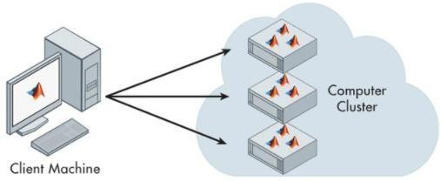

**Cloud resource management**

* + **Critical function** of any man-made system.
  + It affects the **three basic criteria** for the evaluation of a system:

O Functionality.

O Performance.

O Cost.

* + **Scheduling** in a computing system deciding how to allocate resources of a system, such as CPU cycles, memory, secondary storage space, I/O and network bandwidth, between users and tasks.
  + **Policies and mechanisms** for resource allocation.

O Policy: principles guiding decisions.

O Mechanisms: the means to implement policies

# Cloud resources

O Requires complex policies and decisions for multi-objective optimization.

O It is challenging - the complexity of the system makes it impossible to have accurate global state information.

O Affected by unpredictable interactions with the environment, e.g.,system failures, attacks.

O Cloud service providers are faced with large fluctuating loads which challenge the claim of cloud elasticity

* + The **strategies for resource management** for IaaS, PaaS, and SaaS are different.

# Cloud resource management (CRM) policies

O 1. **Admission control:** prevent the system from accepting workload in violation of high-level system policies.

O 2. **Capacity allocation**: allocate resources for individual activations of a service.

O 3. **Load balancing**: distribute the workload evenly among the servers. O 4. **Energy optimization**: minimization of energy consumption

O 5. **Quality of service (QoS) guarantees**: ability to satisfy timing or other conditions specified by a Service Level Agreement

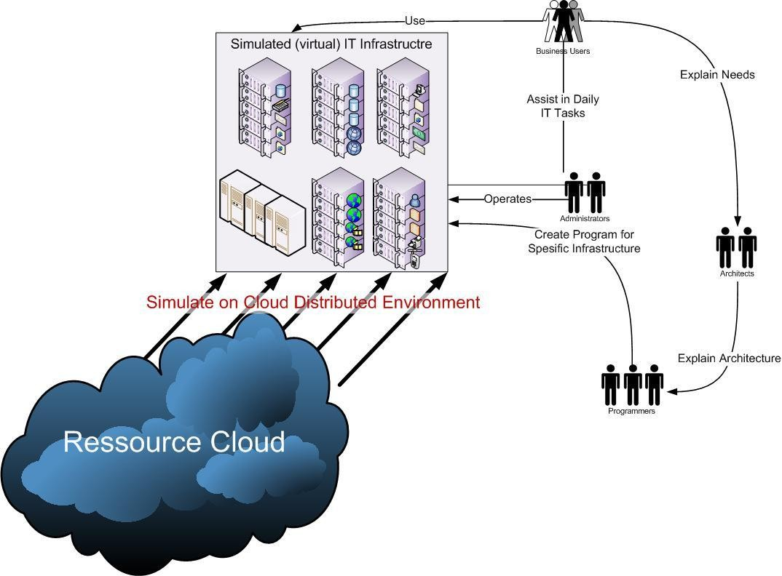

**Dynamic resource allocation**

* + Cloud Computing environment can supply of computing resources on the basis of demand and when needed
  + Managing the customer demand creates the challenges of on-demand resource allocation.
  + Effective and dynamic utilization of the resources in cloud can help to balance the load and avoid situations like slow run of systems.
  + Cloud computing allows business outcomes to scale up and down their resources based on needs.
  + Virtual Machines are allocated to the user based on their job in order to reduce the number of physical servers in the cloud environment
  + If the VM is available then job is allowed to run on the VM.
  + If the VM is not available then the algorithm finds a low priority job taking into account the job’s lease type.
  + The low priority job is paused its execution by pre-empting its resource.
  + The high priority job is allowed to run on the resources pre-empted from the low priority.
  + When any other job running on VMs are completed, the job which was paused early can be resumed if the lease type of the job is suspendable.
  + If not, the suspended job has to wait for the completion of high priority job running in its resources, so that it can be resumed.
  + There are three types

O Cancellable: These requests can be scheduled at any time after their arrival time

O Suspendable: Suspendable leases are flexible in start time and can be scheduled at any time after their ready time

O Non-Preemptable: The leases associated with such requests cannot be pre-empted at all.

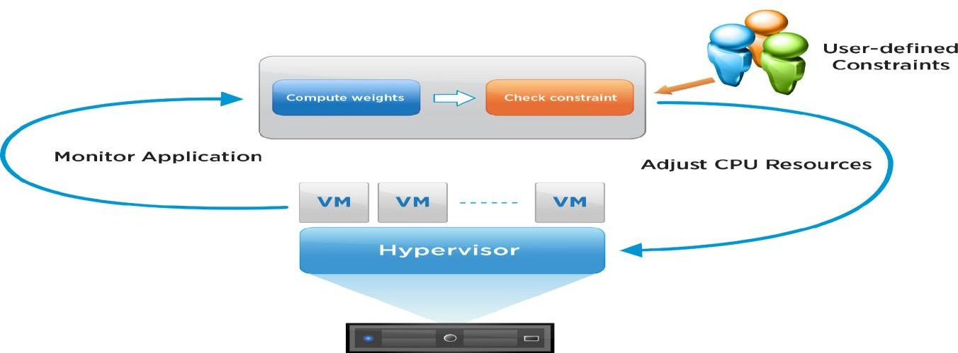

**Optimal allocation of cloud models**

* + The optimal allocation of computing resources is a core part for implementing cloud computing.
  + High heterogeneity, high dynamism, and virtualization make the optimal allocation problem more complex than the traditional scheduling problems in grid system or cloud computing system.

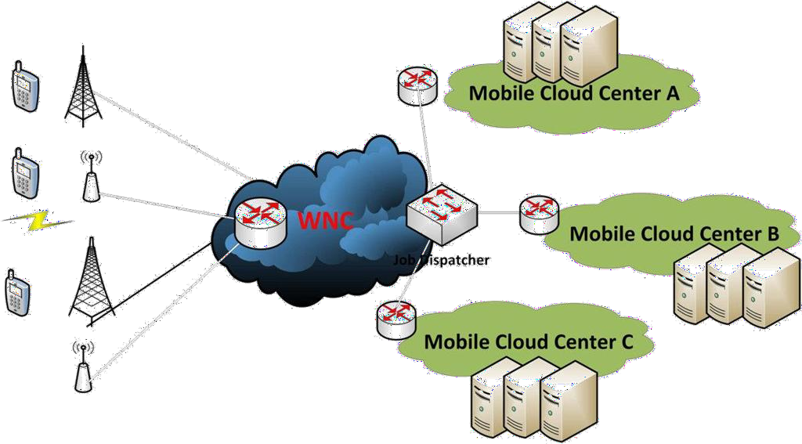

## Cloud-Enabling Technology

Broadband Networks and Internet Architecture

 Data Center Technology

 Virtualization Technology

 Web Technology

 Multitenant Technology

 Containerization

